1.Write a query to Display the product details (product_class_code, product_id, product_desc, product_price,) as per the following criteria and sort them in descending order of category: a. If the category is 2050, increase the price by 2000 b. If the category is 2051, increase the price by 500 c. If the category is 2052, increase the price by 600. Hint: Use case statement. no permanent change in table required. (60 ROWS) [NOTE: PRODUCT TABLE]

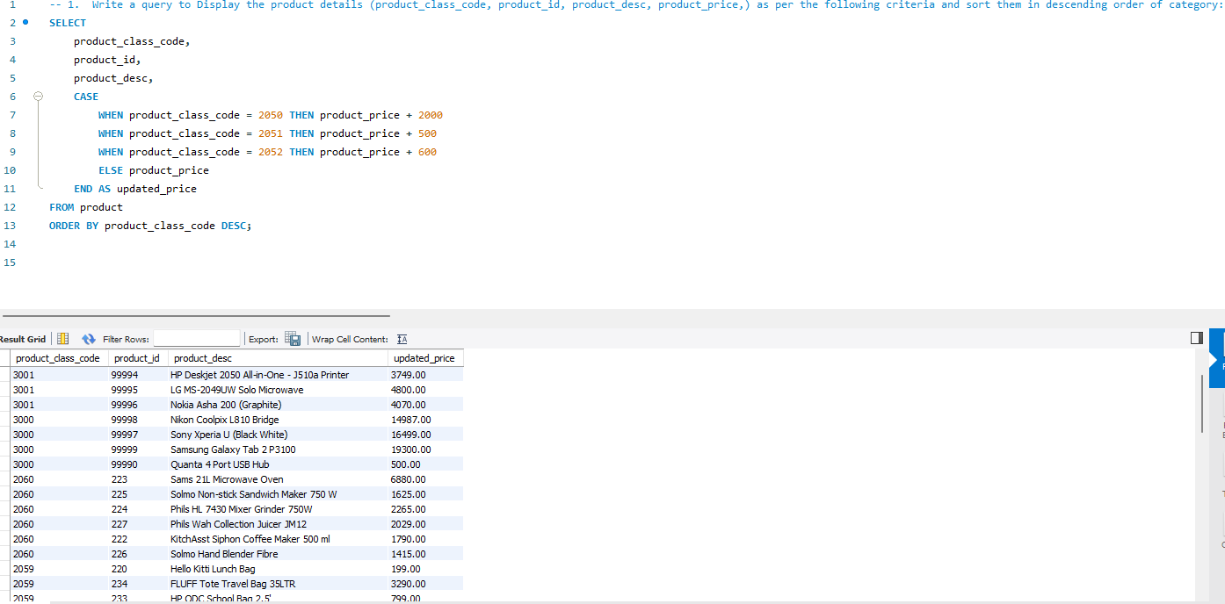

2.Write a query to display (product_class_desc, product_id, product_desc, product_quantity_avail ) and Show inventory status of products as below as per their available quantity: a. For Electronics and Computer categories, if available quantity is <= 10, show 'Low stock', 11 <= qty <= 30, show 'In stock', >= 31, show 'Enough stock' b. For Stationery and Clothes categories, if qty <= 20, show 'Low stock', 21 <= qty <= 80, show 'In stock', >= 81, show 'Enough stock' c. Rest of the categories, if qty <= 15 – 'Low Stock', 16 <= qty <= 50 – 'In Stock', >= 51 – 'Enough stock' For all categories, if available quantity is 0, show 'Out of stock'. Hint: Use case statement. (60 ROWS) [NOTE: TABLES TO BE USED – product, product_class]

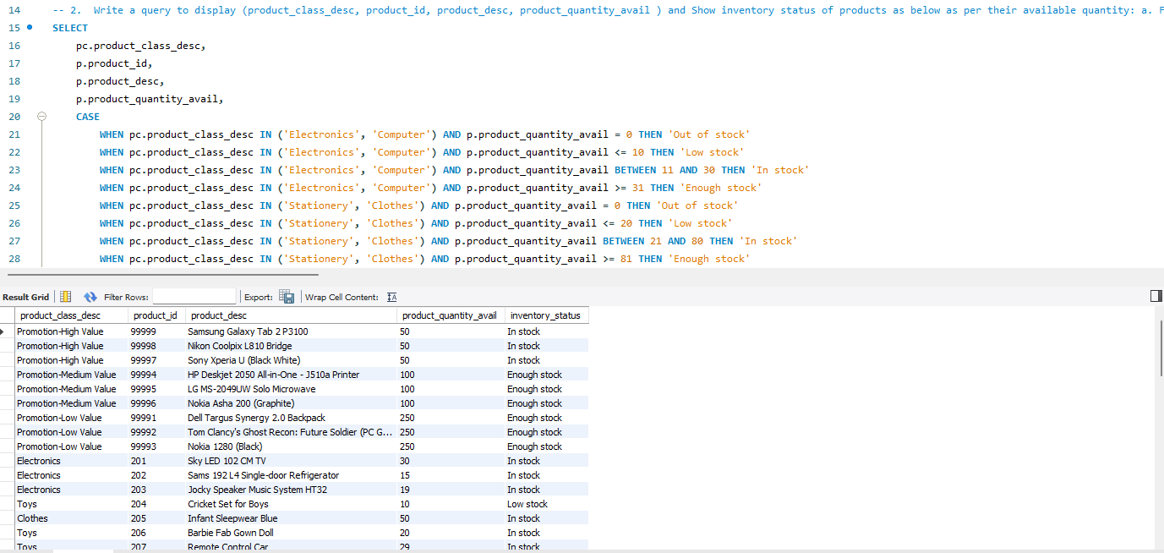

3.Write a query to Show the count of cities in all countries other than USA & MALAYSIA, with more than 1 city, in the descending order of CITIES. (2 rows) [NOTE: ADDRESS TABLE, Do not use Distinct]

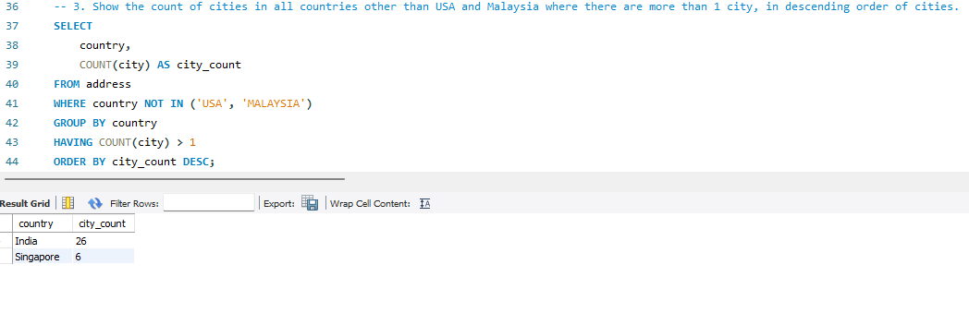

4.Write a query to display the customer_id,customer full name ,city,pincode,and order details (order id, product class desc, product desc, subtotal(product_quantity * product_price)) for orders shipped to cities whose pin codes do not have any 0s in them. Sort the output on customer name and subtotal. (52 ROWS) [NOTE: TABLE TO BE USED - online_customer, address, order_header, order_items, product, product_class]

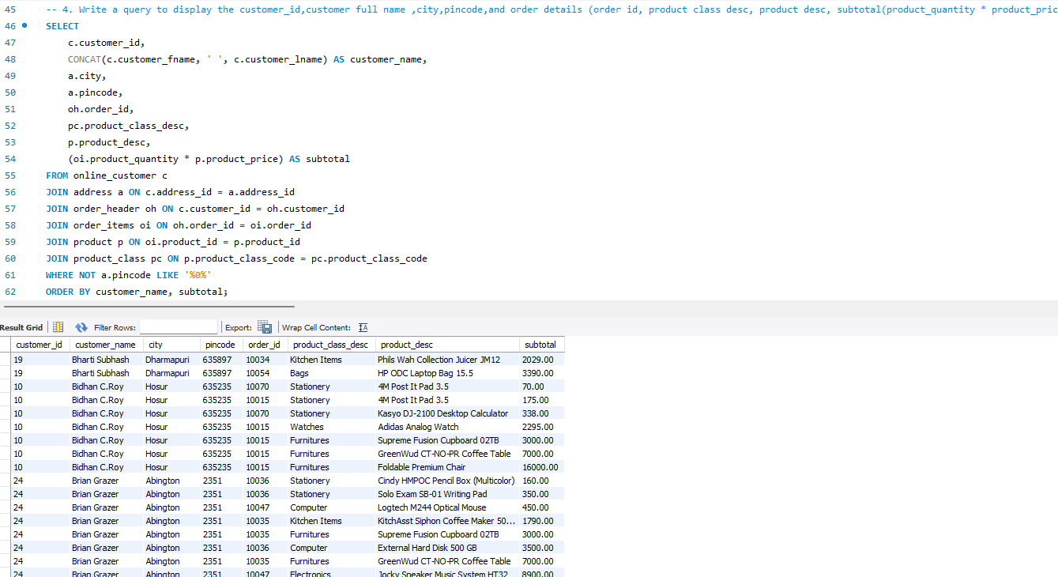52 rows were expected but I manually checked the data for pin code it does not have any zeroes on it in the output.

5.Write a Query to display product id,product description,totalquantity(sum(product quantity) for an item which has been bought maximum no. of times (Quantity Wise) along with product id 201. (USE SUB-QUERY) (1 ROW) [NOTE: ORDER_ITEMS TABLE, PRODUCT TABLE]

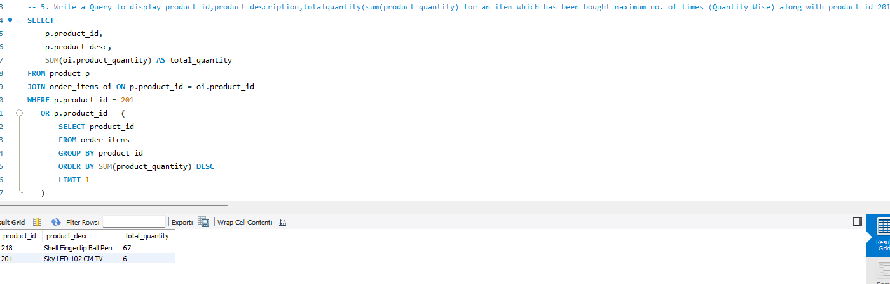2 rows are returned since the Product id 201 doesn't have maximum quantities sold

6.Write a query to display the customer_id,customer name, email and order details (order id, product desc,product qty, subtotal(product_quantity * product_price)) for all customers even if they have not ordered any item.(225 ROWS) [NOTE: TABLE TO BE USED - online_customer, order_header, order_items, product]

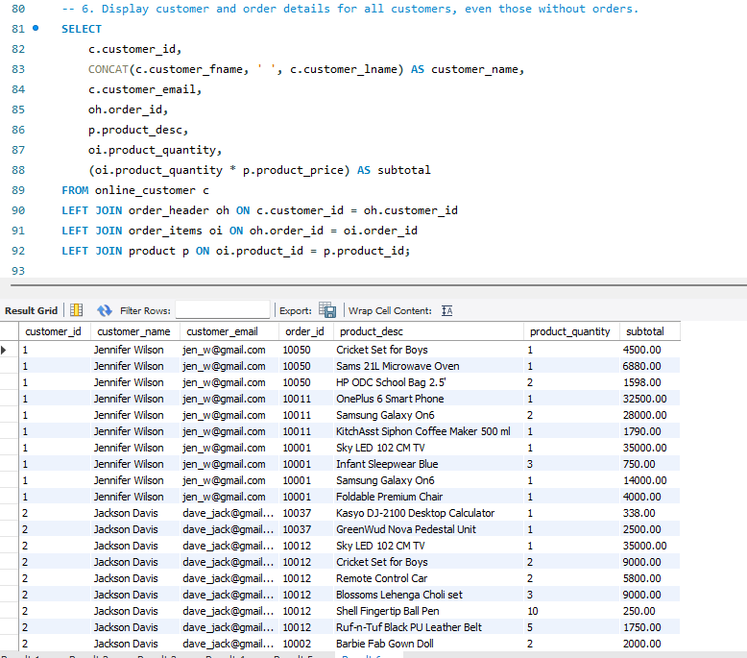

7.Write a query to display carton id, (len*width*height) as carton_vol and identify the optimum carton (carton with the least volume whose volume is greater than the total volume of all items (len * width * height * product_quantity)) for a given order whose order id is 10006, Assume all items of an order are packed into one single carton (box). (1 ROW) [NOTE: CARTON TABLE]

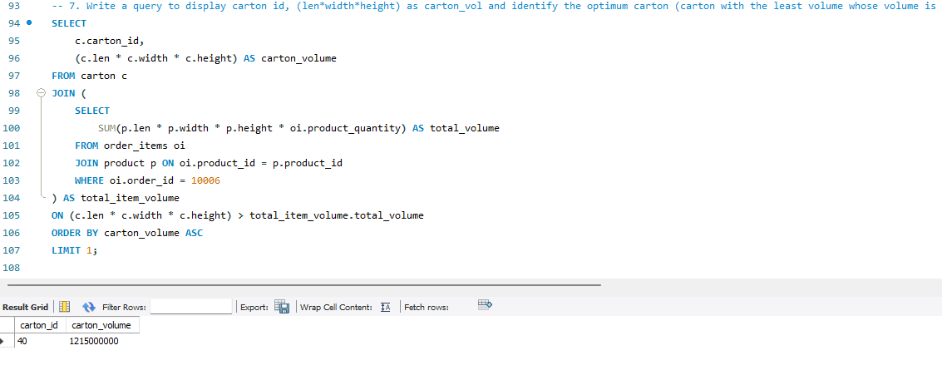

8.Write a query to display details (customer id,customer fullname,order id,product quantity) of customers who bought more than ten (i.e. total order qty) products per shipped order. (11 ROWS) [NOTE: TABLES TO BE USED - online_customer, order_header, order_items,]

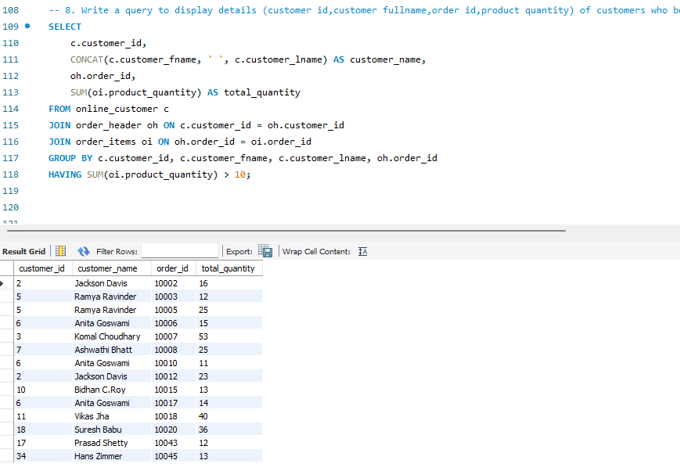

The above query returns 14 rows instead of 11 rows I checked the total quantity column manually. Every value is over 10

9.Write a query to display the order_id, customer id and customer full name of customers along with (product_quantity) as total quantity of products shipped for order ids > 10060. (6 ROWS) [NOTE: TABLES TO BE USED - online_customer, order_header, order_items]

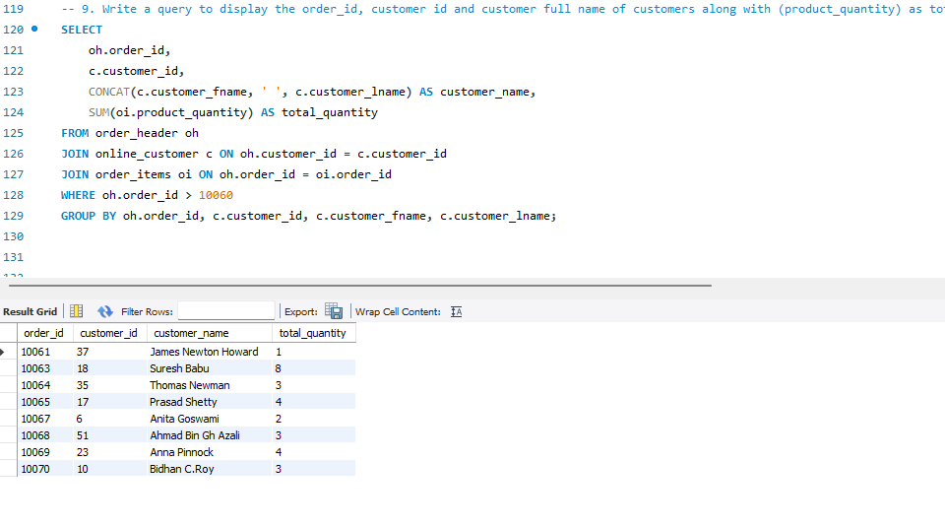 Again, here I checked the table data manually It has 8 instances of unique order ids which are greater than 10060, So the query returns 8 rows and not 6.

10.Write a query to display product class description ,total quantity (sum(product_quantity),Total value (product_quantity * product price) and show which class of products have been shipped highest(Quantity) to countries outside India other than USA? Also show the total value of those items. (1 ROWS)[NOTE:PRODUCT TABLE,ADDRESS TABLE,ONLINE_CUSTOMER TABLE,ORDER_HEADER TABLE,ORDER_ITEMS TABLE,PRODUCT_CLASS TABLE]

